|  |  |
| --- | --- |
|  | **GST 113**  **NIGERIA PEOPLES & CULTURE** |
|  | Sarah AJIYA  Cordelia CLAYTON  Tobi JOHNSON  Dinatu B. TANKO  Felix ODOFIN  Cynthia M. SAIDU |

|  |
| --- |
| **[© 2019]** |
|  |



**LESSON 2**

**PEOPLE OF SOUTHERN NIGERIA**

**MAJOR ETHNIC GROUPS OF SOUTHERN NIGERIA**

We can identify among several others, at least six (06) major ethnic groups in Southern Nigeria. These are the Yoruba, the Igbo, the Bini, the Itsekiri, the Urhobo and the Ijaw.

**THE YORUBA**

The ethnic group now commonly referred to as the ‘Yoruba’ have been identified by different names for centuries. Pacheco Pereira identified them in 1500 as the *Lucumi* while early missionary accounts of the 19th Century referred to them as the *Aku*. Yoruba, which originally referred to the Oyo, began to be used for the generality of the group by the Europeans and it has caught on.

Yoruba is as one of the major ethnic groups in Southern Nigeria. Of course, several members of the Yoruba race can be found everywhere around the globe. But the majority of them are found in some Western and Central States of Nigeria stretching across Oyo, Osun, Ogun, Ondo, Lagos, Kwara and Kogi. They practice both Islam and Christianity but most of them are still traditionalist to the core.

The earliest known account of their existence in the South-West region of Nigeria according to archaeological evidence dates to around 9000 BCE as revealed by human remains at *Iwo Eleru*. The Yoruba ethnic group is believed to have come into existence between 2000-1000 BC. However, their inability to develop arts of writing early in their history gave rise to fables and conflicting accounts of their origin. R.C.C. Law traced the first written account of Yoruba origin to the second Sultan of the Sokoto Caliphate - Sultan Mohammed Bello. In his writing, *Infaq al Maisuri*, Bello in his version in 1812 stated that the Yoruba derived from Nimrod, a descendant of the cursed Ham who fled Mecca while resisting Islam. This account was later appropriated by new Oyo palace historians who expanded it to identify Nimrod as *Lamurudu* whom they now referred to as the father of *Oduduwa*, the acclaimed progenitor of the Yoruba.

**ORIGINS OF THE YORUBA**

Till today, the history of the origins of the Yoruba people remains controversial. The Yoruba, as an ethnic group still holds many versions about its origins.

**Rev. Samuel Johnson’s Version**

In his book, *History of the Yoruba* (1950), Johnson traces the origin of the Yoruba to the “East”. According to him, the Yoruba originally came from the North-Eastern area of Africa – Egyptian Coptic Christians. The similarities between the cultures of the Yoruba and the Egyptians in terms of religious observances, works of arts, burial and other traditional practices are enough evidence. It is from Egypt, after several years of journey that the Yoruba finally settled in Ile-Ife in Nigeria. Oduduwa is believed to be the first leader that led the Yoruba to Ile-Ife and subsequently sent his sons and grandsons to found other Yoruba kingdoms. Johnson’s conclusion is worth recalling:

*That the Yoruba came originally from the East, there cannot be the slightest doubt as their habits, manner and customs, etc., all go to prove. With them the East is Mecca and Mecca is the East. Having strong affinities with the east looming so largely in their imagination, everything that comes from the east with them comes from Mecca, and hence it is natural to present themselves as having hailed originally from that city.*

**The Oke Oramfe’s Version**

Oke Oramfe is located in Ile-Ife. It is believed to be the centre from which the world was created. In their paper *Yorubaland up to 1800,* Akinjogbin & Ayandele (1980) give us a full picture of what Oke Oramfe’s version is all about. According to the legend, there was a period when the world was covered by water. The Almighty God then decided to send some of his messengers to the world and they included Obatala or Orisa Nla or Orisa Alase [as the leader] and sixteen Oye [immortals]. They were given fives pieces of iron, a lump of earth tied to a white piece of cloth, and a cockerel.

Somewhere on their way to the world, the leader, Obatala, got drunk with palm wine. Oduduwa seized the symbol of authority from him and eventually led the party to the world. The site on which they landed is traditionally known as Oke Oramfe in Ile-Ife. On arrival at the site, Oduduwa set down the five pieces of iron and placed the lump of earth on them. The cockerel then spread its toes on the earth. Consequently, the earth was formed and Oduduwa thus became the ruler. It was from this base (Ife) that he extended his authorities to other Yoruba towns and villages.

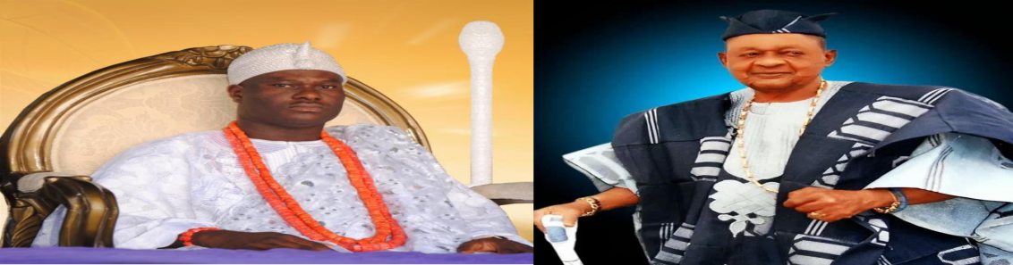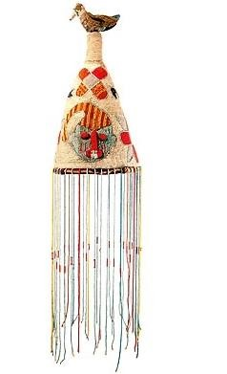

**THE SOCIO-POLITICAL ORGANIZATION OF THE YORUBA**

The Yoruba political system is very complex. The Oba (king) is an absolute ruler with divine authority, yet his powers are checked by various institutions. Kingship rotates among several royal houses; hence, as such the son of a reigning king may not succeed his father. A paramount ruler (the king) seldom appeared in public and was not commonly accessible to his subjects. His subordinate chiefs administered the quarters, villages, the towns and other domains on his behalf. Yet, each of the chiefs has specific traditional duties limited to each of them alone. Yoruba settlement had the Oba’s palace in the centre. Village heads (*Baale*) are subject to the king through his chiefs, while lineage heads (*baale* and *mogaji* in Ibadan) administer the quarters and the wards but are subjected to the immediate higher head. Youths and quarter children have their roles and rights. The rights of women are assured as their leader is an official member of the council of chiefs.

**The Alaafin of Oyo’s Administration**

Oyo is best known as the major kingdom that eventually emerged as an empire in Yorubaland. Various traditions believe that Oyo was founded by Oranmiyan, the son of Oduduwa, who is also credited with establishing the present Benin monarchy. Oyo Empire was founded in the middle of the fifteen century. A century later, it became very powerful and prosperous, extending its authority as far as Dahomey (Republic of Benin). Oyo Empire was very unique and exceptional in its system of government. For instance, in the sixteenth century, Oyo was one of the rare empires that had in-built checks and balances, and, this contributed to its stability for centuries. The Alaafin was the head of the empire, and was resident in the capital. He was also regarded as “Lord of many lands”. The Alaafin was assisted in his administration by a retinue of officials made up of priests, officials and eunuchs. He had a well-organized court as well.

Theoretically, the Alaafin was the fountain of authority and was therefore regarded as the “companion of the gods”. Sometimes, he had an autocratic tendency, but in practice, his powers were often limited and regulated by the Oyomesi, a council of seven members headed by Bashorun who acted as the prime minister. The members of Oyomesi were king makers as well. At the demise of the Alaafin, they were the ones to select his successor. The Oyomesi also had the power to remove any Alaafin especially when he appeared dictatorial or transgressed the laws of the land. Usually the deposed Alaafin was expected to commit suicide.

**The Ogboni Cult’s Administration**

Apart from the Alaafin cabinet, members of the Oyomesi cult constituted another arm of government. It was a very powerful cult. It was composed of free and prominent members of the society as well as members of the Oyomesi. The Ogboni cult had a very vital position in Yoruba society. It played a mediatory role in any conflict between the Oyomesi and the Alaafin. It was a kind of counter power to the Oyomesi as well.

**The Yoruba Army**

The Army was another arm of government in traditional Yoruba society. It was very organized. Its head was conferred with the coveted title of Aare-Ona-Kankanfo. It was made up of infantry and calvary. The Aare- Ona-Kankanfo was expected to live outside the capital. The Army was credited with performing important functions which included stability of the empire, expansion, as well as keeping dissident territories in check. Oyo Empire also had provincial governments. They were modelled after the central government. They were administered by princes, minor kings and baales [provincial governors]. All of them were subject to the over- lordship of the Alaafin. The provincial governments enjoyed considerable autonomy. But the Alaafin had personal agents, Ilari, all over the provinces. The Alaafin used the Bere annual festival periods to acknowledge the renewal of allegiance of the provincial governors to him.

